

Read Me

Allgmeines Programierpraktikum

Frederik Kettel, Philipp Thurow und Maximilian Pesch

Table of Contents

The project 2

The project structure 2

The interface 2

The Player 4

Ant 5

Targets 5

The jar-File 6

The command line arguments 6

# The project

“The Breakthrough-Derivate of the Allgemeinen Programmierpraktikum (BreakthroughPP) is a two player game, where one player (red) plays with red and the other player (blue) plays with blue stones.“

Source: project description

The project can be unzipped with Linux Archive manager or with the Explorer under Windows.

## The project structure

In the root directory of the project you can find a file and a folder. In the source folder contains the source code of the A Game Of Stones Project. The source code provided in the project description is located in the package called “preset”. The preset package also contains another package which contains more Exception Types.

The file that is contained in the root directory is the Ant-Build file.

## The interface

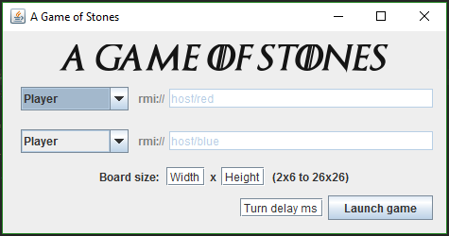

Figure The Game setup

In the select boxes on the left you can chose the type of player that is playing the game. If you want to play yourself, chose the “Player“ option. Otherwise you’ll find the NetPlayer for games over the network or several AIs. If you chose the NetPlayer, you can also change the RMI address if it is not the default.

The input fields for board size and turn delay are optional and will be set to the default values if they are omitted. (Board size: 2x6 und Turn delay: 0 ms)

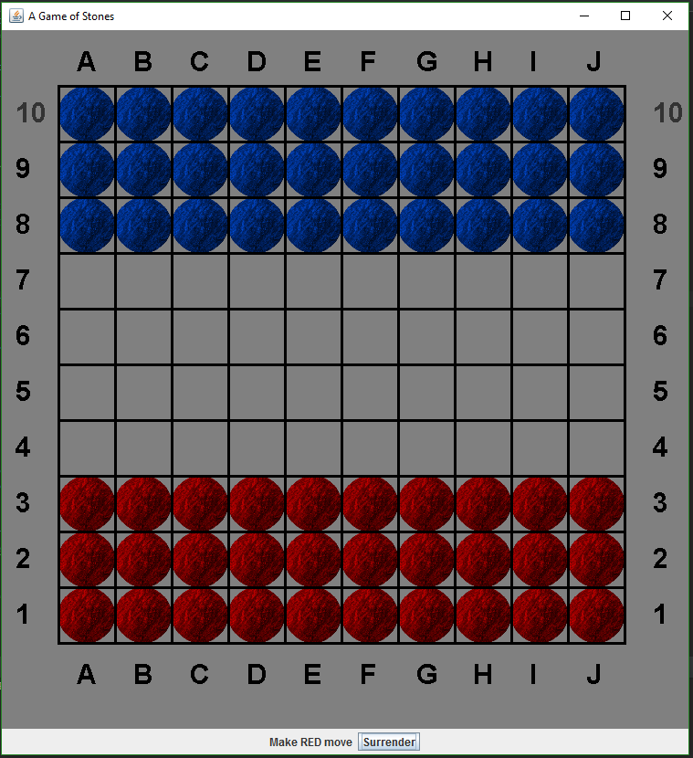

Figure 2 A new 10x10 Brett

As soon as you click on “Launch Game” a new board is generated. The interface is kept simple. At the bottom you can see whose turn it is. Furthermore, the current player has the option to surrender. You make a move by clicking on the stone you want to move and then selecting the destination. After selecting the stone, you want to move the board shows you all possible moves with this stone. If you are red these moves are shown in yellow and if you are blue the possible moves are cyan.

If one player wins this also will be shown on the bottom of the screen.

## The Player

* Player

*This is the human player and waits for the user inputting moves by clicking on the board.*

* Random AI

*The Random Player randomly chooses one of the possible moves. He has no winning strategy.*

* Easy AI

*The Easy AI tries to kill stones where it can, tries to break through and prevents the opponent from winning. If there are moves that satisfy any of those conditions the AI moves randomly.*

* Hard AI

*The Hard AI acts like the project description requires the AI to act to beat the opponent as efficient as possible. In addition to that the AI tries to break through the opponent’s lines if possible.*

* NetPlayer

*To play across multiple computer across the network both sides have to use identical RMI addresses for red and blue. The host (red) becomes the game leader and has to press the Launch Button first, the blue player has 30 seconds to join. After that the game progresses as usual.*

*Games over the Network shouldn’t be interrupted or killed to provide a proper disposal of the RMI[1] addresses.*

# Ant

The Ant- Build file is located in the root directory of the project. It can be used to compile and execute the project as well as for generating the documentation.

## Targets

* compile

*Compiles the project into the build folder. The process of compilation also takes the compiler argument “Xlint:unchecked” into account.*

* clean

*Deletes all the folder which have some kind of build in it. So that you will not have any leftovers from previous compiles.*

* deepClean

*DeepClean does the same as the clean target but it also deletes the documentation generated by the ant build file.*

* dist*[2]*

*The dist target compiles the current version of the A Game Of Stones Project and puts all the files in the build folder together with the assets into an executable jar file whose Main Class is SplinterTheOmniscientRat.*

* javadoc

*This target generates the documentation for all underlying files in the source code with the building Javadoc tool and puts it into the doc directory.*

* run

*The run target produces the jar file as described in the dis target and runs the file.*

# The jar-File

After building the jar-file[3] with ant you can run it. This can be done on the command line as well as just double clicking it. This way you will be directed to the graphical version of the game as described in the interface section.

But the A Game Of Stones Project also has a command line version of the game.

## The command line arguments

* -d or --debug

*Starts the game in the debug mode. That way you will get more information about what is happening in the game. Furthermore, you will also get more output if an error occurs with the Java internal Stacktrace method.*

* -v or --version

*Shows the current version of the game.*

* -h or --help

*This provides an overview on the available arguments and the usage of the debug mode.*

1. *An RMI-Service can be started in the Console with the command "rmiregistry [port]".*
2. dist is short for distribution and contains the die jar-file which can be distributed later on.
3. see Target dist